HAN House model RC Analysis

**Author:** Luca Gennari

**Version:** Draft_V01

**Date:** 17/11/2021

**Contents**

1. Introduction 2

2. Research steps 2

3. Dutch housing typologies and energy consumption 3

1. Dutch energy consumption per private dwellings typologies and per year: 3

2. Most common Dutch housing typologies 4

Terraced houses additional information 5

3. Relevant construction characteristics 5

4. Literature study 7

5. Literature study - Takeaways Summary 20

6. HAN Model - Analysis of the main (current) parameters 21

4. Current RC model 21

7. Possible implementations for the HAN model 27

8. Rc-waarde, Rsi, Rse and U-waarde: a brief explanation 30

9. Follow-up future research steps 31

10. Discussion 33

11. References 34

# Introduction

To support the residential energy transition, tools that allow designers and decision-makers to easily compare renovation options and address their magnitude are necessary. The HAN in collaboration [TO BE COMPLETED] has developed a dynamic simulation ‘grey-box[1]’ tool, with a simple Excel based interface for users (planners, architects, and engineers) to enter their design parameters**. Hereinafter referred to as the *'HAN model'***. The model used is based on an equivalent resistance-capacitance (R-C) model. The building envelope is simulated with an R-C* electrical analogy to model the building thermal mass and heat transfer as respectively (lumped) capacities and resistances. Lumped-capacitance models assume that the distributed thermal mass of the dwelling is lumped into a discrete number of thermal capacitances, depending on the model type (G. Reynders et al., 2014). Whereas state-of-the-art ‘white-box’ building energy simulation models show good performance in validation studies, the number of model parameters and thus the required input data, increases drastically with the model complexity (Glenn Reynders et al., 2015). Grey-box RC models greatly reduce the computational effort.

RC models are mathematically a set of ordinary differential equations (ODEs). For ODEs, the number of orders is equivalent to the number of C terms (Li et al., 2021).

Previous studies have shown a strong dependency between heating energy demand, outdoor environment, building characteristics and efficiency of the control strategy [ref 8 (G. Reynders et al., 2014)]. The HAN model particularly aims to specialise on the simulation of the control strategies.

In this research several RC models have been analysed and compared to the HAN model. The objective is to address the accuracy of the HAN model, identify which modifications to suggest to the HAN RC model and which simplifications can be used to better represent and simulate specific building typologies. Building typologies have been analysed based on the TABULA project (Delf University of Technology, n.d.) and (Agentschap NL, 2011a) data for the Dutch housing situation.

\**Thermal resistance R and capacitance C are defined as:*

* and *

*with thermal conductivity (k), thickness (*x*), density (*ρ*), and specific heat (*Cp*).*

# Research steps

The following workpackages are presented in this report:

* Analysis of the main house typologies in the Netherlands and their construction characteristics
* Literature study of RC network analogy models
  + including simplifications and rules of thumb
* Comparison of the literature study RC models with the HAN RC model
  + Including a check of the equations used in the current HAN model
* Suggestions of implementations for the HAN model RC-layout based on building characteristics and literature study findings.

Follow-up workpackage (further explained at the end of the report):

* Estimation (i.e., quantify magnitude) and validation of the selected RC layouts and possible simplifications to represent specific building typologies through inter-model comparison with a detailed ‘white-box’ dynamic simulation.

# Dutch housing typologies and energy consumption

The following elements of consideration have been analysed:

1. Dutch houses’ average energy consumption per year
2. Dutch houses’ energy consumption per dwelling typology
3. Identify most common Dutch housing typologies
4. Define relevant construction characteristics (such as light floor/roof/walls, high % of glass, cavity ground floor etc.). **NOTE: this point needs further research. See paragraph ‘Follow-up future research steps’.**

## Dutch energy consumption per private dwellings typologies and per year:

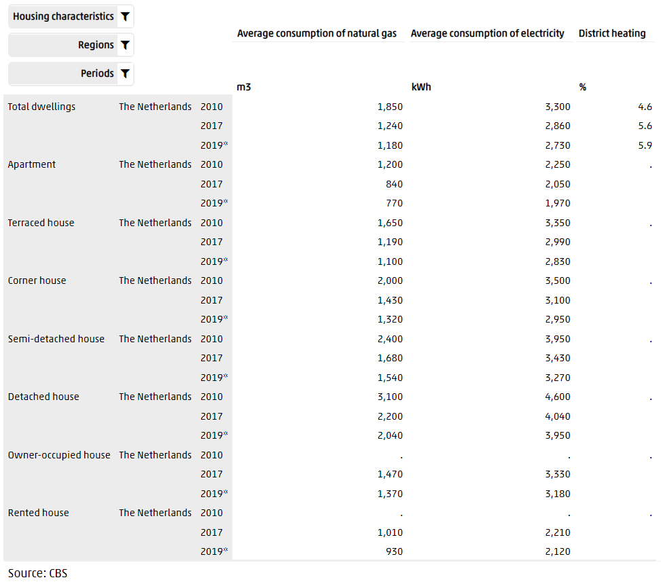

This table shows regional figures on the average consumption of energy (natural gas and electricity) of private dwellings broken down by type of dwelling and ownership for Nederland, group of provinces, provinces and municipalities. Besides, for total dwellings only, the share of heat distribution (district heating) has been added, because this is relevant for the interpretation of the height of the average consumption of natural gas.

Data available from: 2010

Source:(cbs, 2019) <https://www.cbs.nl/en-gb/figures/detail/81528ENG?q=parts%20of%20the%20country>

## Most common Dutch housing typologies

There are five main types of dwellings in the Netherlands:

* *Vrijstaand* (detached)
* *Twee onder een kap* (semi-detached)
* *Rijtjeshuis* (terraced /town house/ row house)
* *Appartement* (apartment)
* *Woonboot* (houseboat)

The most common type of dwelling are the Terraced housing*(rijtjeshuis) and Apartments*.

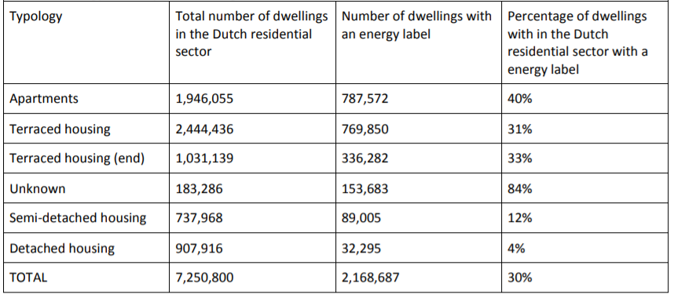**Table**: Overview energy consumption labelling in the Dutch residential sector (adjusted from Kadaster, 2013). **Source**: More connect report from page 81 onwards (van Oorschot, 2016) and (Delf University of Technology, n.d.). The last one can be found online at <https://episcope.eu/building-typology/country/nl.html>.

26% of total

34%

14%

Percentage of the Dutch housing typologies:

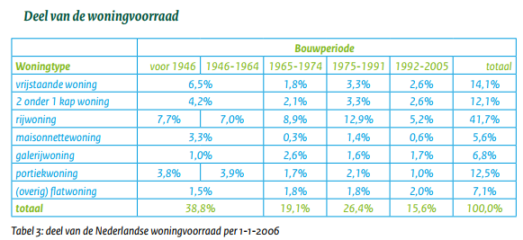

Average energy index (representative of the energy performance, the higher the better):

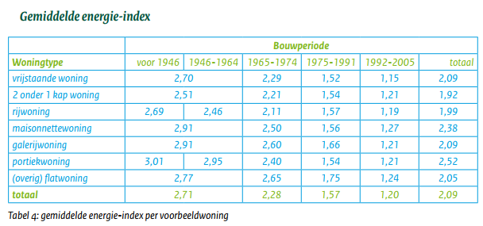

*Source: (Agentschap NL, 2011b)*

Based on the above data, the main attention should go to **apartments and terraced houses** (including terraced-corner - or end - houses) as they are in the largest number. The HAN house model is currently set-up for terraced housed. Particularly relevant are the ones **built before 1974** due to their poor energy performance, which count for around the 24% of the total Dutch house market (data from 2011).

### Terraced houses additional information

Since the 1920’s the housing stock in the Netherlands is dominated by low-rise mass housing development. At first by municipalities and housing corporations, later also by project developers. This has resulted in only a few, very common, typologies which have been used for a large number of houses throughout the Netherlands. The appearance of these houses may vary, but the structure and floor plans are mostly identical.

A very common typology that is developed from the 1950’s onwards is the ‘doorzonwoning’; a type of terraced housing with an open floor plan and large windows in both façades. This typology dominated the mass housing design of the 1970’s and 1980’s. **These dwellings are originally barely insulated and contain –due to the method and speed of construction- many air leaks.** In spite of later renovations and retrofit insulation of these houses, their energy performance is inferior. Despite differences in appearance, detail and energy performance, these houses are quite similar to contemporary mass housing design concerning dimensions and floor plan. The quantity, popularity, structure and potential for improving the energy performance of this housing typology makes it highly attractive for the development of a passive house renovation concept for mass production. Such a concept, with the potential to be repeated on a much larger scale […]

*Source: (Herwin Sap, Ronald Rovers, 2014)*

## Relevant construction characteristics

Additional information about the construction characteristics of Dutch terraced houses should be researched (i.e. frequency of light vs heavy floor/roof/walls, percentage of glass on the facades, presence of a cavity ground floor etc.). This additional research about the envelope (especially which components can be expected as light or heavy) is necessary in order to possibly decide to implement a 3rd order (3 capacities) model for the HAN model (especially in case of mixed use of heavy and light construction elements) or select possible simplifications such as reducing the model to the 1st order (1 capacity) in case of light structures (see coming paragraph ‘Possible implementations for the HAN model’). Possible sources for those pieces of information are the*:*

* *brochure ‘Voorbeeldwoningen 2011 Bestaande bouw’ (Agentschap NL, 2011a),*
* *‘Voorbeeldwoningen 2011 Onderzoeksverantwoording’ (Agentschap NL, 2011b) and*
* *(van Oorschot, 2016) pag. 88 onwards – link to online pdf in the Bibliography.*

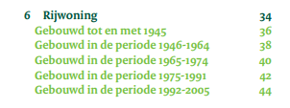

*Fig. Screenshot from ‘Voorbeeldwoningen 2011 Bestaande bouw’ (Agentschap NL, 2011a) table of contents. Possible information about terraced houses construction materials used could be found at page 34 to 40 (up to yr ’74).*

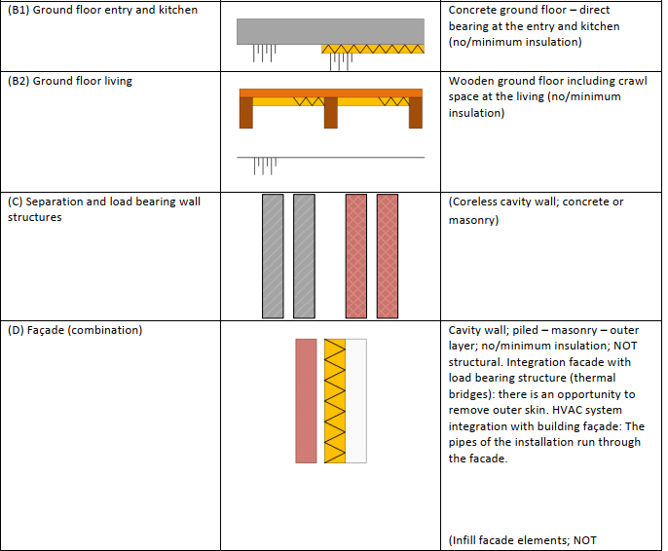

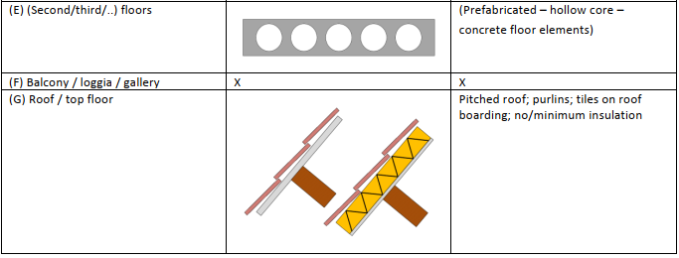

*Fig. Example of envelope and structural materials for a terraced house from 1965 from (van Oorschot, 2016) page 105. The row houses that were built in the period 1965-1974 represent 606,000 dwellings (9%). Almost half (47%) of these dwellings are owned by a private homeowner. An equal portion is owned by social housing associations and about 6% is rented in the private sector.*

# Literature study

The following literature study focuses on previous RC models, form, parameters and main findings (which could lead to guidelines and simplifications for the HAN model). Particular attention goes to the modelling of the effect of the thermal mass (and related representation in the model through the heat capacitance C).

9 publications (4 papers, 4 conference articles and 1 doctorate thesis) have been selected (*the selected literatures are presented in the order of how the research as evolved over time; the numbering 1 to 9 doesn’t follow the numerical order as these publications have been found and selected in different moments. A number has been given at the moment of selection*):

* Ref. 9 (conference): Low-order model for the simulation of a building and its heating system. Older publication, (Gouda et al., 2000). Note: **Precursor of the ‘lumped’ capacity and resistance modelling method.** Named in Ref.7, 8 which are at the base of Ref.2,3. Particularly interesting is the way in which the equations used are specified in a simple way for the different components (building and emission system).
* Ref.1 (Doctorate thesis): Design and analysis of optimal multi-layer walls for time-varying thermal excitation (Bond, 2006)

|  |
| --- |
| * Ref.8 (Journal): Quality of grey-box models and identified parameters as function of the accuracy of input and observation signals (G. Reynders et al., 2014). Note: The **accuracy of different RC models is modelled and compared** with a dynamic ‘white-box’ model. *May 2014*. Glenn Reynders, same author in Ref. 6,7,8. * Ref.7 (conference): Bottom-up modeling of the belgian residential building stock: Influence of model complexity (Glenn Reynders et al., 2014). Note: *December 2014🡺* ***Ref.7 is a follow-up of Ref8.******where a night zone is added*.** Glenn Reynders, same author as in Ref. 6,7,8 * Ref.6 (Journal): Impact of the Heat Emission System on the Identification of Grey-box Models for Residential Buildings (Glenn Reynders et al., 2015). Note:***Ref.6 is a follow-up of Ref7,8. where focus is on the difference in dynamic behaviour between slow floor heating and fast radiators as the heating emissions systems*.**Glenn Reynders, same author as in Ref. 6,7,8 |
| * Ref.3 (conference): Bottom-up Modeling of Residential Heating Systems for Demand Side Management in District Energy System Analysis and Distribution Grid Planning (Kramer et al., 2017). * Ref.2 (conference): Validation of RC Building Models for Applications in Energy and Demand Side Management (Kuniyoshi et al., 2018). Note: Kremer is author of both Ref. 2&3. Its research is based on the work of Glenn Reynders Ref. 6,7,8 |

* Ref.5 (Journal): Energy embodied in, and transmitted through, walls of different type when accounting for the dynamic effects of thermal mass (Reilly et al., 2020). Note: not directly about RC modelling, interesting for the dynamic effect of thermal mass.
* Ref.4 (Journal): Grey-box modeling and application for building energy simulations – A critical review (Li et al., 2021).

**Literature study summary**

* **Ref9** - Low-order model for the simulation of a building and its heating system. Older publication, (Gouda et al., 2000).

|  |  |
| --- | --- |
| **RC model used** | And (equivalent):    *The above RC model is simulated and* ***compared with one week of empirical*** *measurements in an equivalent example space. The red circled temperature is used to highlight a mistake in the publication (T1 should be the indoor air temperature Ti).* |
| **Notes:** | **Precursor research of the ‘lumped’ capacity and resistance modelling method.** This research is named in Ref.7, 8 which are then used as a starting point for Ref.2,3. |
| **Order of the model** | 6th (2 external walls, floor, roof, partitions, indoor air) |
| **Description of the (main) parameters** | 6th order model:      The air capacity C6 is placed in series with the capacity of the indoor partitions C5.  The following state equations are used:    A 1st order lumped model (one capacity) is also described:        Ctotal includes the indoor air capacity.  Rins *includes the internal surface resistance and the resistance of part of the envelope (possibly the part from the center of the insulation layer, facing indoor).  Rout *includes the external surface resistance and the resistance of part of the envelope (possibly the part from the center of the insulation layer, facing outdoor).  Infiltrations and ventilation are not specified.  *\*To determine this the Lorenz and Masy method has been used of which it has been proven difficult to find further specific information.*  Equations used to ‘lump’ R and C in the 1st order model (one capacity): |
| **N. of zones** | 1 |
| **Year of publication** | 2000 (conference paper) |
| **Takeaways:** | * Simplified ‘lumped’ RC models have sufficient accuracy to be used in the design and selection of heating generation/emission systems and related control systems strategies, for buildings with high thermal capacity. * Having just one C (total ‘lumped’ thermal capacity) doesn’t’ t allow for a distinction between the fast dynamics of the indoor air and the slow dynamics of the structural mass.   Others:   * This publication contains useful descriptions of possible equations to model convection heat transfer from radiators as emission system. * A solar algorithm is implemented using Simulink in Matlab. * The impact of solar radiation is not validated in their model. * The impact of light buildings (low thermal mass) is not validated. * Validation is done with data from a short period of time (i.e., one week).   A screenshot from the research conclusion paragraph in support of the above takeaways: |

* **Ref8** - Quality of grey-box models and identified parameters as function of the accuracy of input and observation signals (G. Reynders et al., 2014)

|  |  |
| --- | --- |
| **RC model used** |  |
| **Notes:** | The **accuracy of different RC models (1st to 5th order) is modelled and compared** with another **dynamic ‘white-box’ simulated model**. Glenn Reynders, same author in Ref. 6,7,8. |
| **Order of the model** | From 1st to 5th  4th order model: capacities *Cw*,*C*, *Cwi* and *Ci*  3rd order: simplified by ground floor and envelope capacities  2nd order: simplifies further combining air and internal walls capacity  1st order: all capacities together |
| **Description of the (main) parameters** | *Cw* = Thermal capacity for the exterior walls + roof  *Cf* = the ground floor  *Cwi* = the internal walls  *Ci* = the indoor air  The outdoor temperature (*Te*) and the ground temperature (*Tg*) are used as boundary conditions. |
| **N. of zones** | 1 |
| **Year of publication** | May 2014. |
| **Takeaways:** | * **4th order models had the best results** (5th order showed some improvements for well insulated buildings, but not substantial). In particular, it allows:  1. to simulate separately the capacity of the indoor walls and air 2. to simulate the ground temperature for the floor heat transfer: it extends the 3rd order model by including a separate state for the floor. This state is included because the floor is not in direct contact with the outdoor environment at a temperature Te, but with the ground at a temperature Tground  * As a rule of thumb, the active thermal mass of the envelope corresponds to the thermal mass of the material layers within the insulation barrier*. This means that the **thermal mass of materials before the insulation (facing outdoor) could be neglected.**   *The Cw then becomes (just) the thermal mass of the material layers within the insulation barrier.*   * Using **at least two thermal capacities C (2nd order models)** a distinction can be made between the slow dynamics of the structural mass C1 and the fast dynamics of the indoor air C2, leading to higher accuracy. **For the HAN model, this could be implemented applying the schematic shown below:**     Indoor Air + perimeter walls (bordering other houses) and partition walls  =Rsi  =Renvelope  Envelope (External walls + Roof + Floors)  *\*inner layer of construction has been proven to be the most 'active' in absorbing and releasing heat. See fig. 7 from Ref.8:*     * Additionally, the accuracy of the control strategies for the modelled RC networks have not been satisfactory which highlights the research gap in this area and justifies the choice to focus on the analysis of control strategies with the HAN model. * If a light-weight structure is used for part of the building (i.e., the pitched roof in this publication) dynamics can be expected to differ significantly from the heavy-weight of (here brick) walls, a potential improvement of the model could be achieved by separating the dynamics of the light and heavy structures (i.e., separate the capacities by increasing the order of the model, adding a ‘C’). * The small differences in model structure between a well-insulated and an uninsulated building indicate that *only few model types are needed to represent the majority of buildings*. |

* **Ref7** - Bottom-up modeling of the Belgian residential building stock: Influence of model complexity (Glenn Reynders et al., 2014)

|  |  |
| --- | --- |
| **RC model used** |  |
| **Notes:** | Glenn Reynders, same author as in Ref. 6,7,8.  **Follow-up of Ref8.** **where a night zone is added (the focus of this publication is on modelling 2 zones).** Terraced dwellings are simulated. |
| **Order of the model** | 5th X2 (day and night zones) |
| **Description of the (main) parameters** | The day-zone is modelled with a thermal capacity for the exterior walls (*Cw*), the ground floor (*Cf*), the internal walls (*Cwi*) and the indoor air (*Ci*). The thermal mass of the night-zone is lumped to a capacity for the envelope (roof + walls) (*Cw*), the internal walls (*Cwi*) and the indoor air (*Ci*). Both zones are linked by the internal floor which is modelled by 2 thermal capacities (*Cfi*1) and (*Cfi*2). The outdoor temperature (*Te*) and the ground temperature (*Tg*) are used as boundary conditions.  The thermal resistance of the interior walls is *Rwi*.  The thermal resistance for the envelope is *Rw*.  **The internal resistance (*Rw*1) is defined as the thermal resistance between the indoor environment and the middle of the material layers within the insulation layer**, taking into account also standard heat transfer coefficients at the surface (**including Rsi**). ***Rw*2 is then defined as the thermal resistance between the middle of the layers within the insulation barrier and the outdoor environment** (including Rse)**.**  ***Cw* (envelope and the ground floor) corresponds to the thermal mass of ONLY the material layers within the insulation barrier\*** accordingly to Ref.8 (G. Reynders et al., 2014)  *\*Thermal mass of materials before the insulation (facing outdoor) are neglected.*  **For the HAN model (2nd order) this could be implemented in such diagram:**    C of indoor air + indoor partitions walls + perimeter walls bordering with other houses  C of the envelope after the insulation (i.e., possible load bearing structure if after insulation + internal side of the envelope 15-25mm plaster layer)  Including Rse  Including Rsi  indoor  outdoor  Cavity wall - Designing Buildings  **Outdoor, Rw2 Indoor, Rw1** |
| **Number of zones** | 2 |
| **Year of publication** | December 2014 |
| **Takeaways:** | * The 5 and 4 state model resulted in the best results for respectively the day and night-zone. * A night zone led to overestimated energy consumption especially for well-insulated buildings (built after 2005) * The thermal resistance and capacity of the internal partition (between day and night zones) should be reduced in case of 2-zones models. * Reynders et al. suggest to only take into account the material layers within the insulation barrier for the heat capacitance C, since only the first centimeters of an envelope wall are excited by a heating system. |

* **Ref6** - Impact of the Heat Emission System on the Identification of Grey-box Models for Residential Buildings (Glenn Reynders et al., 2015)

|  |  |
| --- | --- |
| **RC model used** |  |
| **Notes:** | **Latest of the 3 researches selected from** Glenn Reynders et al., same author as in Ref. 6,7,8.  **In this research, focus** is on the difference in dynamic **behaviour between slow floor heating and fast radiators** as the heating emissions systems. |
| **Order of the model** | **4th** |
| **Description of the (main) parameters** | RC representation of the 4th order grey-box model. *Ci*, *Cw*, *Cwi*, *Cf* are respectively the indoor air, external wall, internal wall and floor capacity. *Te* and *Tg* are the air and ground temperature used as input for the model. The solar gains and heating input are not show |
| **Number of zones** | **1** |
| **Year of publication** | **2015** |
| **Takeaways:** | * 1st order model could be sufficient to model floor heating (slow, mostly radiative heat exchange) due to the low-pass filtering effect of the high thermal mass, even a single capacitance model can provide a good approximation in the case of floor heating systems. * 2nd order is necessary to model radiators (different C is needed for the air, because heat transfer is mostly convective). * 3rd order showed the best results (smallest RMSE) but it showed over-parameterization issues. * Not only the lay-out of the RC-network, but also the way that heating and solar gains are introduced have a significant impact on the reliability of the models and the estimated parameters |

* **Ref.3** - Bottom-up Modeling of Residential Heating Systems for Demand Side Management in District Energy System Analysis and Distribution Grid Planning (Kramer et al., 2017).
* **Ref.2** - Validation of RC Building Models for Applications in Energy and Demand Side Management (Kuniyoshi et al., 2018).

Kremer is author of both publications. They are here presented together.

|  |  |
| --- | --- |
| **RC model used** | **Main analysed 6R4C model:**    **Ref. 2 which focuses on floor heating, introduces additional resistances:**    𝑅𝑟𝑎𝑑𝐴𝑊/𝐹𝐿 is added to represent the long-wave radiation.  𝑅𝑟𝑎𝑑𝐴𝑊/𝐹𝐿 is calculated as 1⁄(𝛼𝑠𝑡𝑟 ∙ 𝐴𝐹𝐿) with a radiant heat transfer coefficient 𝛼𝑠𝑡𝑟 = 5 W/m2K  and the area of the floor 𝐴𝐹𝐿 [m2] based on the VDI 6007.  Also the convective superficial resistances are separated from the envelope and floor resistances:    𝛼𝑐𝑜𝑛 = convective coefficient. An internal convective coefficient of 2.7 W/(m²K) is adopted. |
| **Notes:** | * The main aim is to investigate the accuracy of RC models for the simulation of large districts energy demand to support the management of district energy systems (such as Smart Grid and District Heating). * These models are based on the German standard VDI 6007, international Standard 13790: 2008 and on the work of Glenn Reynders (Ref. 6,7,8). * In Ref.2 the focus is on the simulation of floor heating for a standalone, well insulated house. * Ref.3 focuses on model predictive control strategies for energy management. For that 4 representative typologies for the German building stock of standalone houses are modelled. * Inter-model comparison with EnergyPlus is used for validation. |
| **Order of the model** | **4th** |
| **Description of the (main) parameters** | 𝑇𝑎 = Ambient temperature = T. outdoor on the external surface  𝑇z = Zone temperature = Air T. indoor  𝑇𝑔 is assumed to be 10 ℃.  The shortwave radiation from the sun absorbed by the external surfaces of the building components is considered by introducing a modified equivalent ambient temperature 𝑇𝑎,𝑒𝑞    Other temperatures are derived in such a way:    The heat losses due to ventilation and infiltration are calculated as follows:    where 𝑐𝑎𝑖𝑟 is the volumetric specific heat of air [J/m3K], 𝑉𝑧𝑜𝑛𝑒 is the volume of the zone air [m3], 𝜂 are the ACH (volume air change rates per hour) [1/h] for natural ventilation, infiltration and mechanical ventilation and 𝜀 is the efficiency of heat recovery of a mechanical ventilation system [-].  𝜂𝑣𝑒𝑛𝑡 + 𝜂𝑖𝑛𝑓 = 0,5 [1/h]  𝜂𝑚𝑒𝑐 = 0,55 [1/h]  Efficiency of heat recovery = 0,84% |
| **Number of zones** | **1 (single)** |
| **Year of publication** | **2017** and **2018** |
| **Takeaways:** | * Envelope resistances are spitted into 2 (as suggested by G. Reynders et al., 2014) * RC models (‘grey-box’) have good potential in the support of district energy management by predicting energy demand dynamically. * (Ref 2) Increasing the number of thermal resistances gives better results (a similar conclusion is in Ref. 4). In this publication the added resistance has a focus on the floor heating accuracy. * Additional insight about modelling floor heating can be found in Ref.2. |

* **Ref4** - Grey-box modeling and application for building energy simulations – A critical review (Li et al., 2021)

|  |  |
| --- | --- |
| **RC model used** | N.A. |
| **Notes:** | This research is **a literature review on its own**. With **many interesting insights** on the overall RC modelling context and possibilities. Worth reading especially for the developers of the mathematical approach used to solve the target simulation values, modelling language and control systems. |
| **Order of the model** | N.A.  Based on this literature review, 2nd order grey-box modelling is the top pick of previous researchers.    Sample text and image about some analysed researches for single-zones models:  “[…] The 5R1C model according to ISO13790 was used to model a residential building. The hourly cooling and heating load agreed well with EnergyPlus simulation results [77]. Analytical solutions were proposed for simplified RC building models with a set of different orders: 5R2C, 4R2C, 2R2C, and 1R2C [78]. The results showed that the proposed solutions had good agreement with the measurement data and EnergyPlus results. A comparison was performed between 5R1C and 7R2C models to a residential building based on ISO13790 and German Guideline VDI 6007, respectively. The results showed that the 7R2C model had better accuracy and was acceptable for heating and cooling load prediction [79] […] |
| **Description of the (main) parameters** | Structure of the discussed paragraphs in this literature review article: |
| **Number of zones** | N.A. |
| **Year of publication** | 2021 |
| **Takeaways:** | * Several RC models are analysed and compared. * Most model use 2 capacities with good results (small error). * To increase the accuracy, the number of thermal resistances could be increased without affecting the computational effort required. (A similar conclusion in Ref. 2). * Many of the analysed researches used the International Standard **ISO13790** [Energy performance of buildings] and the German Guideline **VDI 6007** as a reference when preparing RC models. Note that ISO13790: 2008 has been replaced by **ISO 52016:2017** |

# Literature study - Takeaways Summary

Based on literature studies, there are numerous representations of RC models. RC models are usually formatted into xRyC, in which x is the number of thermal resistances, and y is the number of thermal capacitances. RC models are normally quantified by their ‘order’, the order is often defined by the number of capacities in the model. So e.g., a 1st-order model will have just one capacity.

Some of the literature study main findings are below summarized into a list which includes possible simplifications and rules of thumb for RC modelling:

* Use at least two thermal capacities C (2nd order models) so that a distinction can be made between the slow dynamics of the structural mass C1 and the fast dynamics of the indoor air C2 (leading to higher accuracy).
* A minimum of 2 capacities (2nd order model) is suggested, up to 4 (more than 4 seem not be particularly relevant, causing over-parameterization issues (Ref 6, 7, 8). It could have some benefit to increase the HAN model to the 3rd order (3 capacities) but that would increase the computational effort (as the number of C defines the order of the differential equations). On the other hand, increasing the number of R could allow a higher degree of accuracy without compromising the low computational effort as suggested in Ref. 4 (Li et al., 2021).

It could be beneficial, for instance, to introduce a separate resistance in parallel for the ground floor (see ‘Step 3’ as in ‘Possible implementations for the HAN model’).

* As a rule of thumb, the active thermal mass of the envelope corresponds to the thermal mass of the material layers within the insulation barrier (since only the first centimeters of an envelope wall are excited by a heating system). This means that the thermal mass of materials before the insulation (facing outdoor) could be neglected.

Source: Ref.7 and 8. (G. Reynders et al., 2014)

* It is suggested to divide in two parts the internal resistance of the envelope (facades’ walls, ground floor and roof). The two resulting resistances could be: 1) the thermal resistance between the indoor environment and the middle of the insulation material layer (including Rsi) and 2) the between the middle of the insulation layer and the outdoor environment (including Rse).
* Only few model types are needed to represent the majority of buildings. (G. Reynders et al., 2014) (Ref. 8).
* In case of mixed light and heavy envelope components, it could be beneficial to separate them into two different capacities (G. Reynders et al., 2014) (Ref. 8).
* Not only the lay-out of the RC-network, but also the way that heating and solar gains are introduced have a significant impact on the reliability of the models and the estimated parameters (Ref. 6).
* RC modelling can be of good support in the analysis of demand-side management of energy networks for large scale renovation projects (such as heating generation when provided by heat pumps and connected to a smart grid) or district heating, due to the lower computational effort.
* The International Standard **ISO13790** (Energy performance of buildings: 7.2.2 Simple hourly method) and the German Guideline **VDI 6007** both could be used to improve the model as both were cited multiple times and describe procedures for RC modelling to simulate the thermal behaviour (copy of ISO13790:2008 can be found at <https://www.nen.nl/en/nen-en-iso-13790-2008-en-122104>). Note that ISO13790:2008 has been replaced by **ISO 52016:2017** (copy can be found at <https://www.nen.nl/en/nen-en-iso-52016-1-2017-en-236338>. See: ‘7.3 Hourly method: validation in case of specific alternative calculation procedures’. And calculations described in 6.5.6.3). Note also that, in case alternative models are used, ISO 52016:2017 provides a verification case for validation “[…] Alternative options for the subdivision of each construction elements into a number of nodes of thermal resistances and capacitances are allowed, provided that the verification cases in 7.2 are applied to validate the method […]”.
* Validation of RC models has often been done through inter-model comparison and in fewer cases through empirical data comparison. In the first case, a ‘grey-box’ RC model is compared with a ‘white-box’ model with same characteristics (materials, form, environmental bordering conditions etc.).

# HAN Model - Analysis of the main (current) parameters

The following analysis is based on the Excel ‘Tussenwoning’ used as a tool for preparing the HAN Model (‘grey-box’) RC parameters for the dynamic simulation.

## Current RC model

RC layout:

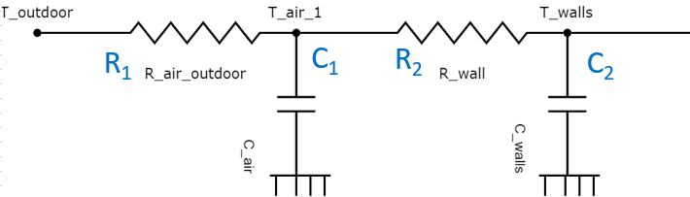

RC layout explanation based on analysed Excel (insights are presented in the below tables):

|  |
| --- |
| Tout (or To ; Te )  R1 = Renvelope + Ventilation  C1= Indoor Air + 15mm plaster   * Facades’ plaster, 15mm * Internal walls plaster (2x) 15mm, * Roof plaster 15mm   C2 = load bearing structure   * G. floor concrete (‘concrete’) * 1st floor (indoor) concrete * Attic floor (indoor) concrete * Perimeter (structural= concrete) walls bordering with other houses (=no heat transfer)   R2 = Rsi/A = surface resistance (=convection+radiation)  Tin |

Summary table of the R-C parameters:

|  |  |  |  |
| --- | --- | --- | --- |
| **Name:** | | **Description:** | **Unit** |
| R_air outdoor | **R1** | Lumped' Resistance includes: | K/W |
|  |  | * Windows |  |
|  |  | * Façade walls (including insulation) |  |
|  |  | * Roof (including insulation) |  |
|  |  | * Ground floor (including insulation) |  |
|  |  | * Ventilation (with heat recovery) |  |
|  |  | * Air infiltrations (infiltration and natural ventilation together) |  |
|  | | | |
| *Note:*   * *Rso* currently is not considered (*see paragraph* ‘Rc-waarde, Rsi, Rse and U-waarde: a brief explanation’ *for more information*) * *I suggest separating the ventilation losses* | | | |
|  |  |  |  |
| C_air | **C1** | * Indoor air capacity (for the indoor volume of air) | J/K |
|  |  | * + Capacity of the internal side of the envelope (roof+façade walls 15mm plaster layer). |  |
|  |  | * + internal partition walls (2x15mm plaster) |  |
|  |  | (Afacade_no-windows +Ainterior_walls+Aroof)∙cplaster_15mm + Volume_indoor*Density_air*cair |  |
| * If this is the internal capacity, why is it located before R2 (Rsi, internal surface resistance) and C2 (structural materials capacity)? | | | |
|  |  |  |  |
| R_wall | **R2** | = Rsi/A (Inside surfaces resistance. Taking into account convection and radiation on surface) | K/W |
| *Note:* | | | |
| * *Missing the area of the facades-walls (instead wall bordering with other houses are used)* * *Missing area of roof (instead 2xAttic is used)* * *Areas of interior partitions (such as attic, floor between g.f. and 1st-floor and walls bordering with other houses, could be considered adiabatic and neglected)* | | | |
| * *The used Rsi (=0,13 m2K/W) is valid only for horizontal heat transfer (i.e., vertical walls.* See paragraph ‘Rc-waarde, Rsi, Rse and U-waarde: a brief explanation’ *for more information*)*. Here it is applied also for vertical heat exchange (I.e., floor and roof). But this should lead to minor effect as Rsi for roof is normally 0,1.* | | | |
|  | | | |
|  |  |  |  |
| C_wall | **C2** | Thermal capacity of load-bearing construction, including: | J/k |
|  |  | * Ground floor |  |
|  |  | * Intermediate floor (between ground and 1st floor) |  |
|  |  | * Attic floor |  |
|  |  | * Perimeter-wall, bordering other houses (so not insulated and without heat transfer as not bordering with outdoor temperature Te but with another heated environment) |  |
|  |  | *= cp_concrete \** *Density_concrete *(Aground_floor * dThickness_groundfoor + Aintermediate_indoor-floor * dThickness_foor+ Aattic_floor * dThickness_Attic-foor+ 2*APerimeter-walls_bordering-other-houses* dThickness_* *Perimeter-walls )* |  |
| * This should be placed before (from outdoor to indoor) C1 (internal air and walls capacity). Currently the effect of the thermal resistance of the envelope is not perceived by this capacity *(for suggestions, see paragraph ‘Possible implementations for the HAN model’).* | | | |

Detailed table about the R-C parameters a in the Excel ‘Tussenwoning’:

|  |  |  |  |
| --- | --- | --- | --- |
| **Term C1** | **Formula as in Excel** | **‘Sheet’Cell** | **unit** |
| Capacity  C1 | ='Prepare_Data '!B31 | ‘YAML_XLS’D25 | J/K |
| Warmtecapaciteit intern  C1 | =((B29+B12)*B30)+(B36*Referentie_data!B3*Referentie_data!B4)  Add missing parenthesis. | 'Prepare_Data '!B31 | ~~kJ/K 🡺~~ J/K  Correct unit  Check:  = |
| **(Afacade_no-windows +Ainterior_walls+Aroof)∙cplaster_15mm + Vindoor*Density-air*cair** | | | |
| Totaal oppervlak wanden  *Total surface of walls (it includes the indoor surfaces of both partition walls and facade walls)* | =B10 + B26*2+B27*2  *=Afacade_no-windows + 2*Ainterior_walls_1st-floor +2*Ainterior_walls_ground-floor* | 'Prepare_Data '!B29 | m2 |
| Roof surface = Aroof | *value* | 'Prepare_Data '!B12 | m2 |
| Heat capacity surface internal walls (15 mm plaster) | *value* | 'Prepare_Data '!B30 | J/m2K |
| Net air volume  *(indoor volume)* | *value* | 'Prepare_Data '!B36 | m3 |
| Density air | *value* | Referentie_data!B3 | kg/m3 |
| Specific heat capacity air | *value* | Referentie_data!B4 | J/kgK |
| **Term C2** | **Formula as in Excel** | **‘Sheet’Cell** | **unit** |
| Capacity  C2 | ='Prepare_Data '!B50 | ‘YAML_XLS’D29 | J/K |
| Warmtecapaciteit constructie (C2) | =B49*B48*B46 | 'Prepare_Data '!B50 | J/K  Check:  = |
| *= cp_concrete \** *Density_concrete \**  *(Aground_floor * dThickness_groundfoor + Aintermediate_indoor-floor * dThickness_foor+ Aattic_floor * dThickness_Attic-foor+*  *2*APerimeter-walls_bordering-other-houses* dThickness_* *Perimeter-walls )* | | | |
| Specifieke warmte  *Specific heat capacity = cp*  *(of concrete)* | *value* | 'Prepare_Data '!B49 | J/kgK |
| Dichtheid  *Density (of concrete)* | *value* | 'Prepare_Data '!B48 | Kg/m3 |
| totaal volume *(of load-bering materials)* | =B37*B38+B39*B40+B41*B42+  2*B43*B44  *=Aground_floor * dThickness_groundfoor + Aintermediate_indoor-floor * dThickness_foor+ Aattic_floor * dThickness_Attic-foor+*  *2*APerimeter-walls_bordering-other-houses* dThickness_* *Perimeter-walls* | 'Prepare_Data '!B46 | m3 |
| **Term R1** | **Formula as in Excel** | **‘Sheet’Cell** | **unit** |
| Conductance 1/R1  (R1=Resistance) | =1/'Prepare_Data '!B24 | ‘YAML_XLS’D24 | W/K |
| Warmteweerstand schil R1  *(Heat Resistance envelope + Air infiltration and ventilation)* | =1/((B7/B9+B10/B11+B12/B13+B14/B15)+((B17*(1-B21)+B22)*~~Referentie_data!B2~~*Referentie_data!B4))  Referentie_data!B2 should be removed & 2 missing parenthesis | 'Prepare_Data '!B24 | K/W  Check: |
|  | | | |
| Totaal glasoppervlak *(total glass area)* | *value* | 'Prepare_Data '!B7 | m2 |
| Rc-waarde glas | *value* | 'Prepare_Data '!B9 | m2K/W |
| Totaal gesloten oppervlak gevel  *Total surface façade (façade ‒ windows area)* | *value* | 'Prepare_Data '!B10 | m2 |
| Rc-waarde gevel = R*walls façade, including insulation (when present).* | *value* | 'Prepare_Data '!B11 | m2K/W |
| Roof surface | *value* | 'Prepare_Data '!B12 | m2 |
| Rc-waarde dak | *value* | 'Prepare_Data '!B13 | m2K/W |
| Opervlak vloer  *Groundfloor Area* | *value* | 'Prepare_Data '!B14 | m2 |
| Rc vloer | *value* | 'Prepare_Data '!B15 | m2K/W |
| Ventilatie *(mechanical Ventilation)* | *=B16/3600*Referentie_data!B3*  *= m3/hr/3600*kg/m3=m3/s*kg/m3=kg/s*  *Value (basic mech. ventilation) =100m3/h= 0,36 ACH (= 100 [m3/h]/275,6[m3]). In line with* [*ASHRAE recommendation (min 0,35 ACH*](https://www.epa.gov/indoor-air-quality-iaq/how-much-ventilation-do-i-need-my-home-improve-indoor-air-quality)*)* | 'Prepare_Data '!B17 | Kg/s |
| Warmteterugwining bij gekozen ventilatiesysteem *efficiency heat recovery mech. Vent.* | *value* | 'Prepare_Data '!B21 | - |
| Infiltrations of air  Including natural ventilation?  Probably yes, since it is equivalent to 1 ACH. | *=INDEX(Referentie_data!B11:B12,B19)*INDEX(Referentie_data!B15:B17,B18)/(10*1000)*B28*Referentie_data!B3*  *=0,09kg/s*  *=0,09[kg/s]*3600/1,2[kg/m3]=270m3/h*  *=1ACH (270[m3/h]/275,6[m3]).* | 'Prepare_Data '!B22 | Kg/s |
| Specific heat capacity air | *value* | Referentie_data!B4 | J/kgK |
| **Term R2** | **Formula as in Excel** | **‘Sheet’Cell** | **unit** |
| Conductance 1/R1  (R1=Resistance) | =1/'Prepare_Data '!B51 | ‘YAML_XLS’D28 | W/K |
| Weerstand tussen intern woning en bouwmassa (R2)  *Rsi inner layer superfical resistance* | =1/('Prepare_Data '!B$45*Referentie_data!B$7) | 'Prepare_Data '!B51 | K/W  Check:  = |
|  | | | |
| Totaal oppervlak  *(total area)* | *=B37+2*B39+2*B41+2*B43*  *= Aground_floor +2* Aintermediate_indoor-floor+2* Aattic_floor+2* APerimeter-walls_bordering-other-houses*   * Missing the area of the facades-walls (instead walls bordering with other houses are used). * Missing area of roof (instead attic and GF/1st floor - =interior floors - are used). * Areas of interior partitions (such as Aattic, floor between g.f. and 1st-floor and walls bordering with other houses, can be considered adiabatic and so neglected). | 'Prepare_Data '!B$45 | m2 |
| Warmte overdrachtscoëfficiënt tussen intern woning en muur  *=1/Rsi* | *Value = 1/Rsi_Horizontal = 1/0,13 = 7,7*   * *Approximated to 8* * *Rsi=0,13 is valid just for horizontal heat transfer (i.e., vertical walls)* | Referentie_data!B$7 | W/m2.K |
| Rsi |  |  | m2K/W |

# Possible implementations for the HAN model

Maintaining 2nd order (2 capacities):

1. 2nd order (2R2C = 2 capacities and 2 resistances). **Drawback**: both thermal mass of load bearing structure and plaster layer (on top of air and interior partition walls capacity) are located after (facing indoor) the resistance which includes the insulation layer. **This could lead to over estimation of the effect of the thermal mass.**

|  |
| --- |
| Indoor Air + perimeter walls (bordering other houses) and partition walls  =Rsi  =Renvelope  Envelope (External walls + Roof + Floors) |

Fig. Based on Ref.8. (G. Reynders et al., 2014) literature study findings.

1. 2nd order (2R2C). **Improvement from previous network**: The thermal mass of the envelope can be divided between the most active part (after the insulation, facing indoor) and the less active. This is done by splitting the thermal resistance of the envelope into 2. This should result in **more realistic effect of the thermal mass.**

**Possible drawback (in order of importance)**:

1. Ground floor heat transfer cannot be simulated independently with a bordering Tgroung (so either neglected or overestimated using bordering Tenvironment).
2. Not possible to separate day and night zones.
3. Not possible to separate the capacity of the indoor air from that of the indoor partition (i.e., internal floors and walls).

|  |  |
| --- | --- |
| C of indoor air + indoor partitions walls + perimeter walls bordering with other houses  C of the envelope after the insulation (i.e., possible load bearing structure if after insulation + internal side of the envelope 15-25mm plaster layer)  Including Rse  Including Rsi  indoor  outdoor | Cavity wall - Designing Buildings  **Outdoor, Rw2 Indoor, Rw1** |
| Based on Ref.7 (Glenn Reynders et al., 2014) and Ref.6 (Glenn Reynders et al., 2015) lit. study findings.  **The internal resistance (*Rw*1) is defined as the thermal resistance between the indoor environment and the middle of the material layers within the insulation layer** (including Rsi). ***Rw*2 is then defined as the thermal resistance between the middle of the layers within the insulation barrier and the outdoor environment** (including Rse)**.** | |

The above approach is suggested and specified in the steps below:

*(see the ppt ‘possible RC changes’ for the modifiable images files)*

|  |  |
| --- | --- |
|  |  |
| ***Switch and Move*** *(in particular, C1 represents the envelope thermal mass while C2 the inner walls, floors, and indoor air heat capacity).* ***Note.*** *The above current model is arranged to represent terraced houses but could be easily adapted to other houses typologies. The literature study also confirms that only few model types are needed to represent the majority of buildings.* | |

|  |  |
| --- | --- |
|  | *Divide the heat transfer resistance of the envelope in two parts, where the point of separation is at the middle of the insulation layer.*  *Separate the ventilation heat losses from the envelope resistance.* |
|  | *(Optional) Separate the resistance of the ground. Ground temperature can so be separated from the outdoor environment temperature.*  *As simplification, ground temperature could be set as a constant (average ground T).* |

The above scheme could be duplicated to simulate separately a day and night zone (see an example in the RC-model of Ref. 7).

Increasing the order to 3rd order

A 3rdh order model could also be implemented (adding a capacity) in the HAN model for buildings where there is a **mixed use of heavy and light elements** in the envelope (i.e., light roof and heavy walls, or heavy ground floor and light walls+roof). Whether adding a capacity is necessary could be verified through comparison with dynamic ‘white-box’ simulations. An example from Ref. 6 where the capacity of the ground floor (‘f’) is separated from that of the envelope (‘w’):

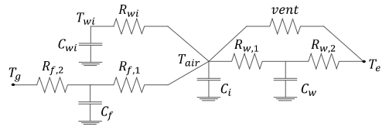

*Fig. R6C4 example from reference 6 (Glenn Reynders et al., 2015).*

This could be relevant for the ‘**doorzonwoning**’ with a mix of light and heavy construction elements, where possibly the external wall could be considered as **light envelope structure (C0), the roof, ground floor as heavy envelope structure (C1) and internal partitions (floors, walls) plus the indoor air as internal capacity (C2)**.

**NOTE:** that if the ‘doorzonwoning’ envelope is all made of a light-weight structure (both light facades and roof) the capacity could be reduce to the **1st order** (1C model). Where all the thermal mass is of the internal walls and floor is coupled with that of the indoor air. While the thermal mass of façade and roof could be possibly neglected. This 1C possible option requires further investigation (possibly through inter-model validation as suggested in the ‘Follow-up future research steps’ paragraph).

# Rc-waarde, Rsi, Rse and U-waarde: a brief explanation

|  |
| --- |
| *U Value equationU values for Dummies | EcomerchantImage source:* [*https://www.ecomerchant.co.uk/news/u-values-for-dummies/*](https://www.ecomerchant.co.uk/news/u-values-for-dummies/)  Rsi and Rse accordingly, to EN ISO 6946 : 2007 ([see](http://tea.ie/wp-content/uploads/2011/09/Module-3.2-Resistance-of-air-layers-and-surface-layers.pdf?fbclid=IwAR3dHlNxE73YbB2RPaodcbKx9NHslnQ3C9Y1LO3C3UGAVn1xqVYQfCav6qc)): |
| When using values of RC-waarde from the Dutch Building regulation (‘Bouwbesluit’ or NEN1068), Rsi and Rso are already included in the 'Rc-waarde' values, used in HAN model R1. See:    *Image source:* [*https://www.takkenkamp.com/kennisbank/rc-waarde/*](https://www.takkenkamp.com/kennisbank/rc-waarde/)  *See also:* [*http://lanten.nl/bouwbesluit_2012/rc-waarde-berekenen/*](http://lanten.nl/bouwbesluit_2012/rc-waarde-berekenen/)  The correction factor alpha is normally set at 5% (<https://www.isover.nl/beng-website/de-optimale-rc-waarden-voor-in-de-gevel.html>) |

# Follow-up future research steps

The next suggested step should include the validation of the suggested simplified RC model (see ‘Possible implementations for the HAN model’) for different building typology and the quantification (i.e., magnitude) of the effect of the simplifications.

First, additional research about the envelope (especially which components can be expected as light or heavy) of the main Dutch building typologies (i.e., terraced houses) is necessary in order to possibly decide to implement a 3rd order (3 capacities) model (see previous paragraph ‘Relevant construction characteristics’ and ‘Possible implementations for the HAN model’).

The xRyC, selected models have to be implemented in the HAN model software. Note that calculations for the "*subdivision of each construction element into a number of nodes of thermal resistances and capacitances*" are described in 6.5.6.3 of ISO 52016:2017. This could also be of support in the further development of the HAN model.

Then a validation of the model can be performed.

|  |
| --- |
| “  “ |

*[Text cited from Ref9 (Gouda et al., 2000)]*

From the three above cited validation method, I suggest the **inter-model comparison** for validating the RC configurations implemented in the HAN model. Some of the reasons of this suggestion are:

* the large availability nowadays of dynamic simulation software which one can clearly explain how they behave (‘white-box’ models), with high degree of reliability.
* the lack (or burdensome to implement) of an available experimental setup.

Some examples of available commercial ‘white-box’ software with a dynamic simulation module as a reference: Designbuilder (EneryPlus interface), IESVE, IDA-ice, TRNSYS, Rhino (with Ladybug and Grasshopper), Vabi.

The choice of the software is often related to its use and level of complexity.

I suggest Designbuilder, an EnergyPlus interface. This is often the choice for researchers and lecturers of building physics and services when the primary goal is to simulate the integrated behaviour of building envelope, installations (i.e. generation) and other heat gains. See as an example this discussion in ResearchGate: <https://www.researchgate.net/post/Which-software-is-best-for-performing-building-energy-analysis>. Additionally, this software come with a discounted fare for students, and it has a visual interface which makes easier to build the model.

ISO 52016:2017 also provides a verification case for validation “[…] *Alternative options for the subdivision of each construction elements into a number of nodes of thermal resistances and capacitances are allowed, provided that the verification cases in 7.2 are applied to validate the method* […]”. This could also be applied in the validation process. In that case, I suggest using the input parameters (such as geometry, materials properties, ventilation ACH etc.) described in 7.2 from the beginning, both in the HAN model and in the (‘white-box’) EnergyPlus (Designbuilder) model.

Finally, I suggest to cross reference the order of magnitude of the results from the different RC networks implemented in the HAN model with national statistical data such as (Delf University of Technology, n.d.) and (Agentschap NL, 2011a).

# Discussion

RC modelling can be of great support in the analysis of demand-side management of energy networks such as for large scale renovation projects concerning energy saving measures, due to its lower computational effort.

In particular, with the transition of heating systems to electrical heat pumps, models that can accurately predict heat demand with minimum computational effort are increasingly useful to guarantee a reliable power supply from smart grids.

HAN house model could be also used to quantify the impact of Future Factory large scale renovations within a smart grid and possibly contribute to real-time predictions of demands to match the smart grid supply. For this, the model should possibly reach a higher level of accuracy.

**Pending internal (HAN meet- en regeltechniek group) questions**

* How ‘easy’ is to implement to a higher order the HAN RC model?
* Is in the interest of the HAN model (based on its future applications) to be able to simulate separate day and night zones?
* Is Future Factory and/or our research group interested in modelling also apartments as typology?

# References

Agentschap NL. (2011a). *Voorbeeldwoningen 2011 Bestaande bouw*. *Publicatie*-nr. *2KPWB1034*. www.voorbeeldwoningen.nl.

Agentschap NL. (2011b). *Voorbeeldwoningen 2011 Onderzoeksverantwoording*. *Publicatie*-nr. *2KPWB1036*, 38.

Bond, D. E. M. (2006). *DESIGN AND ANALYSIS OF OPTIMAL MULTI-LAYER WALLS FOR TIME-VARYING THERMAL EXCITATION*.

cbs. (2019). *Energy consumption private dwellings; type of dwelling and regions*. https://www.cbs.nl/en-gb/figures/detail/81528ENG?q=parts of the country

Delf University of Technology. (n.d.). *TABULA project - Housing typologies Netherlands*. Retrieved October 20, 2021, from https://episcope.eu/building-typology/country/nl.html

Gouda, M. M., Danaher, S., & Underwood, C. P. (2000). Low-order model for the simulation of a building and its heating system. *Building Services Engineering Research and Technology*, *21*(3), 199–208. https://doi.org/10.1177/014362440002100308

Herwin Sap, Ronald Rovers, M. V. (2014). *the “Existing district of tomorrow”; a concept for quick an clean passive house renovation for mass housing in the Netherlands*. https://www.researchgate.net/publication/262399331_the_’Existing_district_of_tomorrow’_a_concept_for_quick_an_clean_passive_house_renovation_for_mass_housing_in_the_Netherlands

Kramer, M., Jambagi, A., & Cheng, V. (2017). *Bottom-up Modeling of Residential Heating Systems for Demand Side Management in District Energy System Analysis and Distribution Grid Planning*. https://doi.org/10.26868/25222708.2017.183

Kuniyoshi, R., Kramer, M., & Lindauer, M. (2018). *Validation of RC Building Models for Applications in Energy and Demand Side Management*.

Li, Y., O’Neill, Z., Zhang, L., Chen, J., Im, P., & DeGraw, J. (2021). Grey-box modeling and application for building energy simulations - A critical review. *Renewable and Sustainable Energy Reviews*, *146*, 111174. https://doi.org/10.1016/J.RSER.2021.111174

Reilly, A., Kinnane, O., & O’hegarty, R. (2020). Energy embodied in, and transmitted through, walls of different types when accounting for the dynamic effects of thermal mass. *Journal of Green Building*, *15*(4), 43–66. https://doi.org/10.3992/JGB.15.4.43

Reynders, G., Diriken, J., & Saelens, D. (2014). Quality of grey-box models and identified parameters as function of the accuracy of input and observation signals. *Energy and Buildings*, *82*, 263–274. https://doi.org/10.1016/J.ENBUILD.2014.07.025

Reynders, Glenn, Diriken, J., & Saelens, D. (2014). *Bottom-up modeling of the belgian residential building stock: Influence of model complexity*. https://www.researchgate.net/publication/303750596_Bottom-up_modeling_of_the_belgian_residential_building_stock_Influence_of_model_complexity

Reynders, Glenn, Diriken, J., & Saelens, D. (2015). Impact of the Heat Emission System on the Identification of Grey-box Models for Residential Buildings. *Energy Procedia*, *78*, 3300–3305. https://doi.org/10.1016/J.EGYPRO.2015.11.740

van Oorschot, J. (2016). *HOUSING TYPOLOGY ASSESSMENT MORE-CONNECT WP3.1*. https://www.more-connect.eu/wp-content/uploads/2019/07/MORE-CONNECT_WP3_D3.1-Overview-of-main-building-types.pdf

1. Based on the provided definition, the grey-box model is a representation of physical model but ignores minor fidelity and preserves major fidelity (Li et al., 2021).